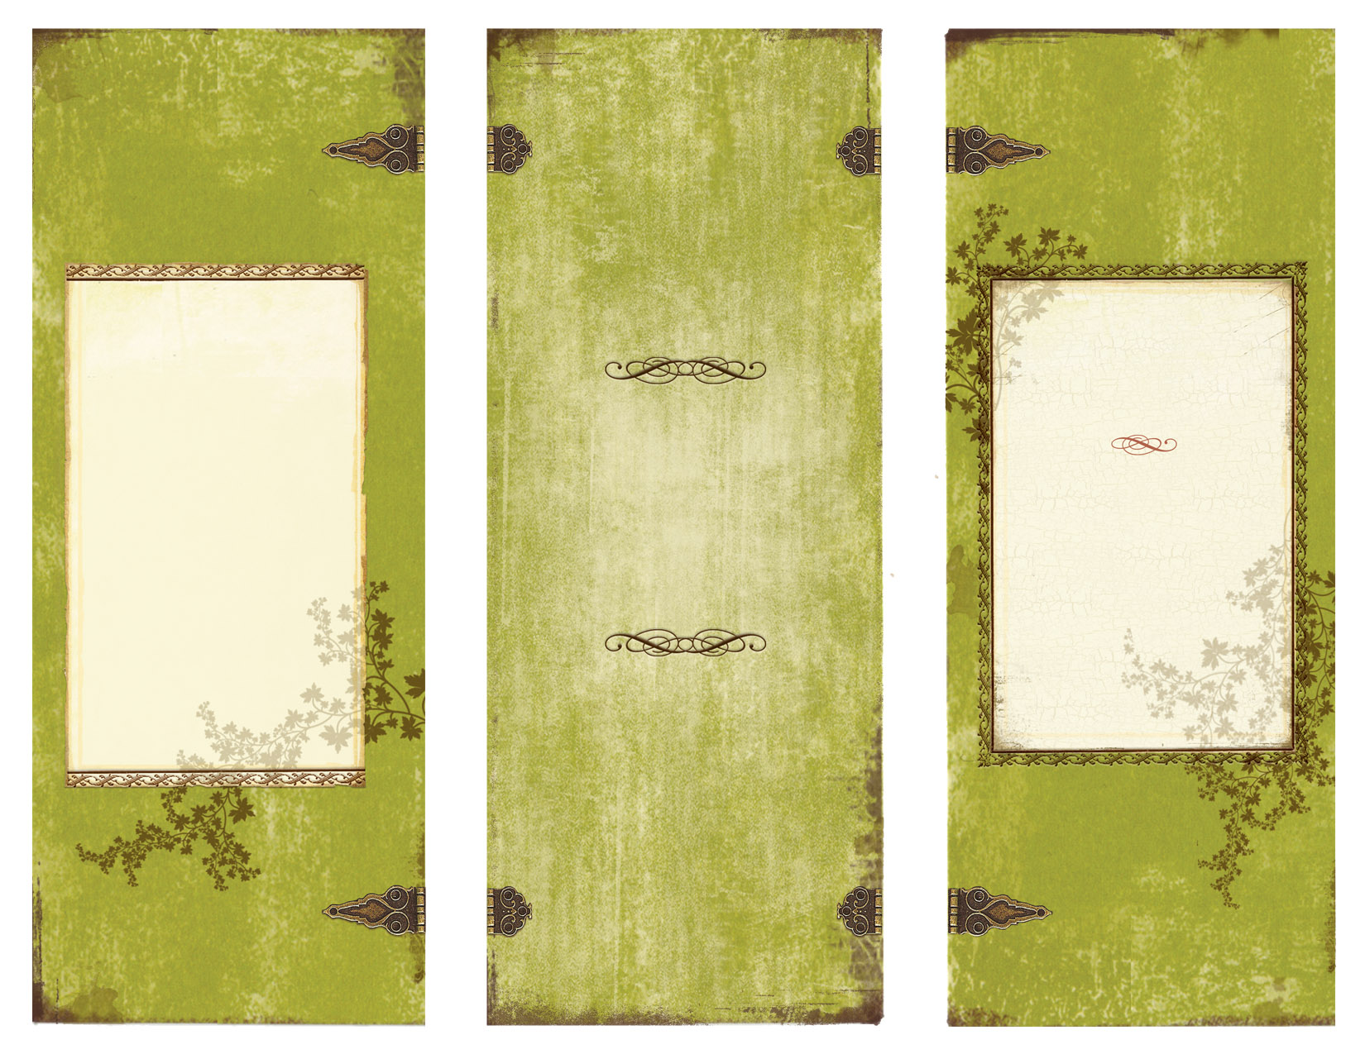

The Great Wall of china was constructed because the Chinese wanted to keep out their enemies. It was used as a barrier to separate the Mongols and the Chinese during the Ming Dynasty. The Great Wall of China today is over 13,000 miles.

WWW.WEBADDRESS.COM

Honors History

Pd.1

Amanda James

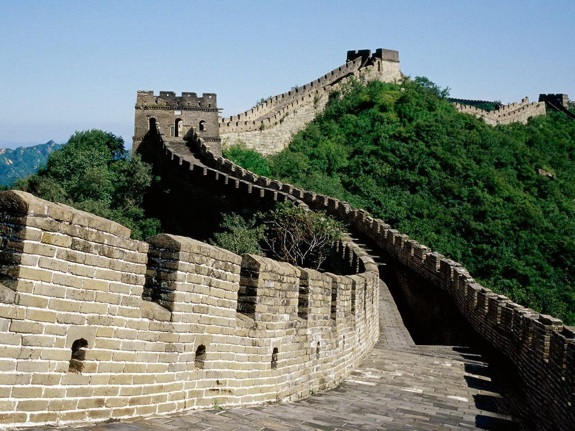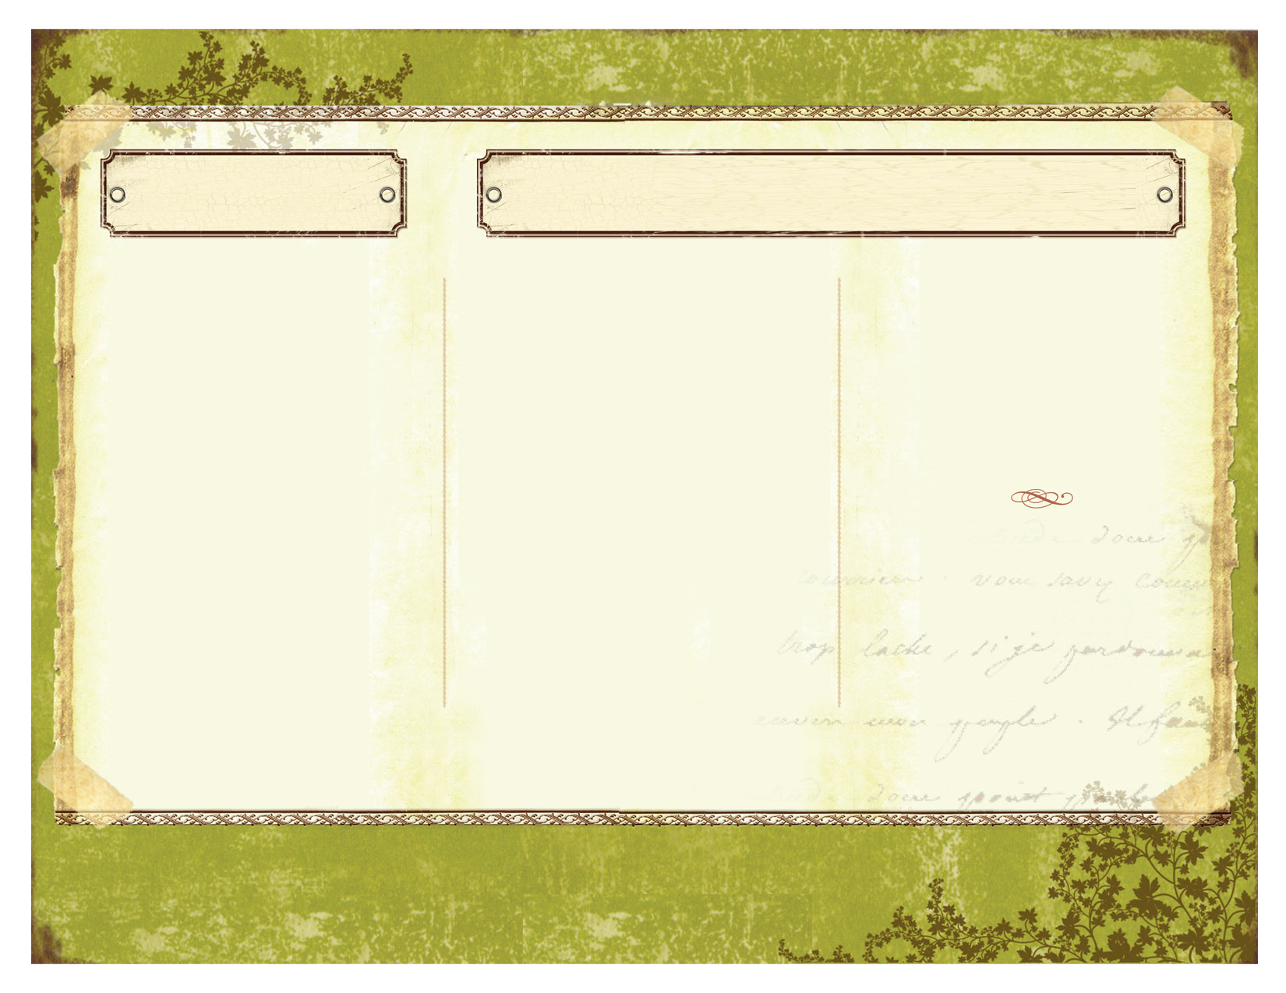

History

How to Build the Great Wall of China

Citation

"Great Wall -." Great Wall -. N.p., n.d. Web. 12 Dec. 2013.

“When the wall was made only with earthen materials, a lot of labor was not needed. But when the Chinese switched to stones, bricks, and granite blocks, much more work was required to lift and move these heavier materials. Three hundred thousand prisoners, peasants, and others disliked by the emperor were conscripted to leave their families and jobs for years and years at a time to help construct the Great Wall.”

* Greatwall

The Great Wall of China took many years to finish. Lots of lives were also lost during the process. There are accounts of people being smashed by stone. Many dynasties contributed on this monument.

Tools and things needed

The Great Wall